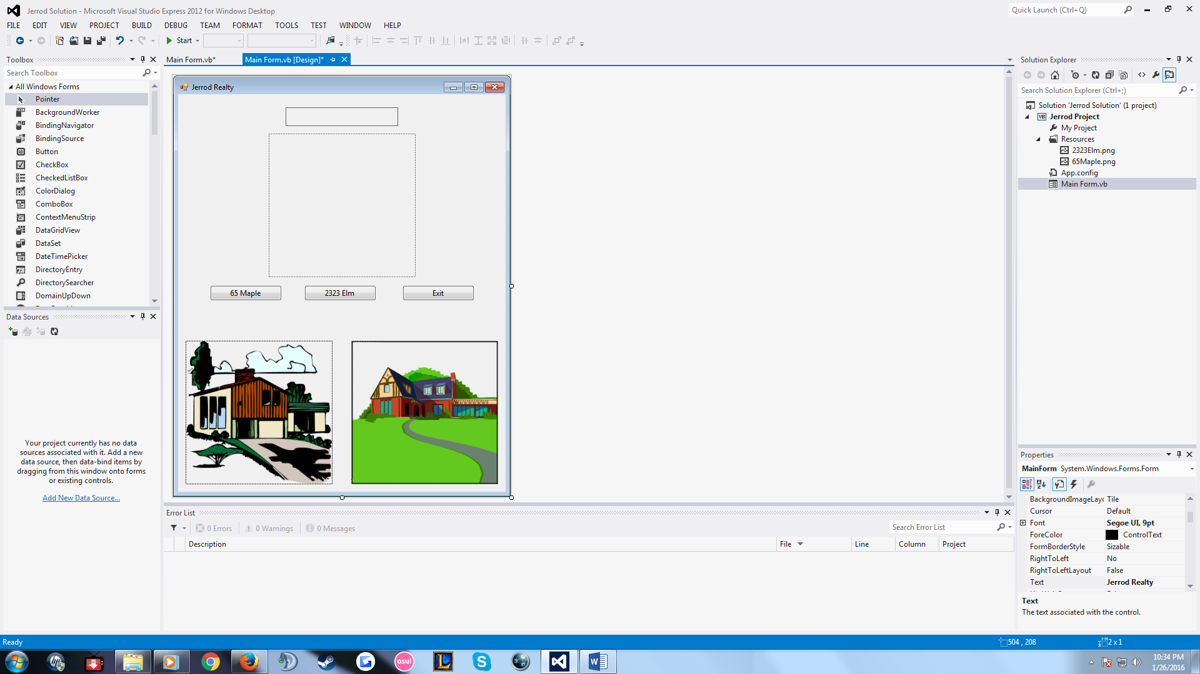

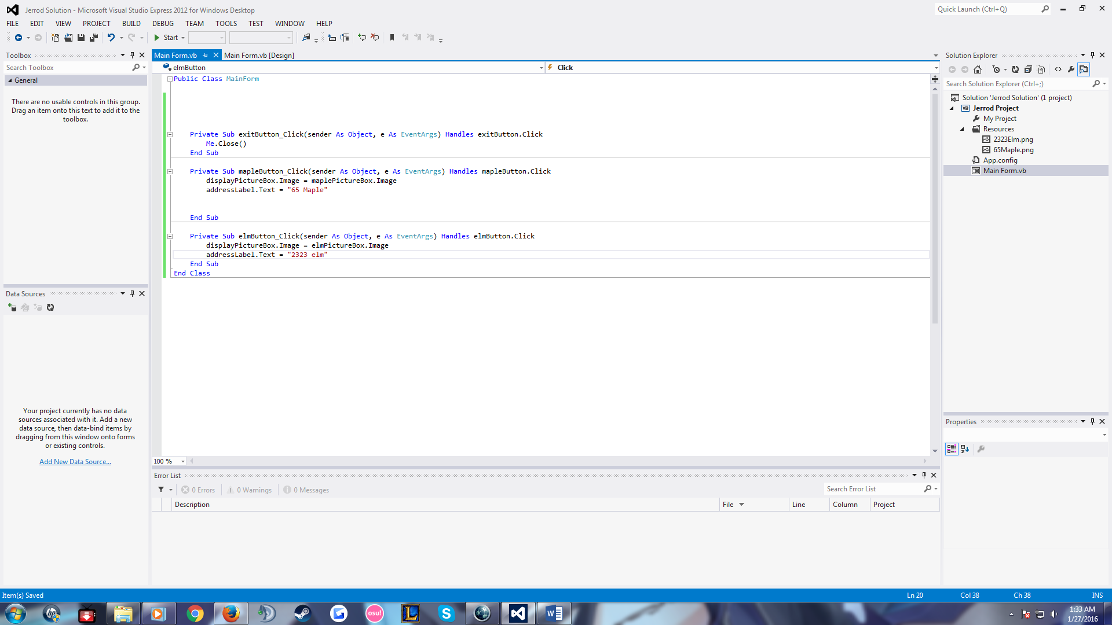

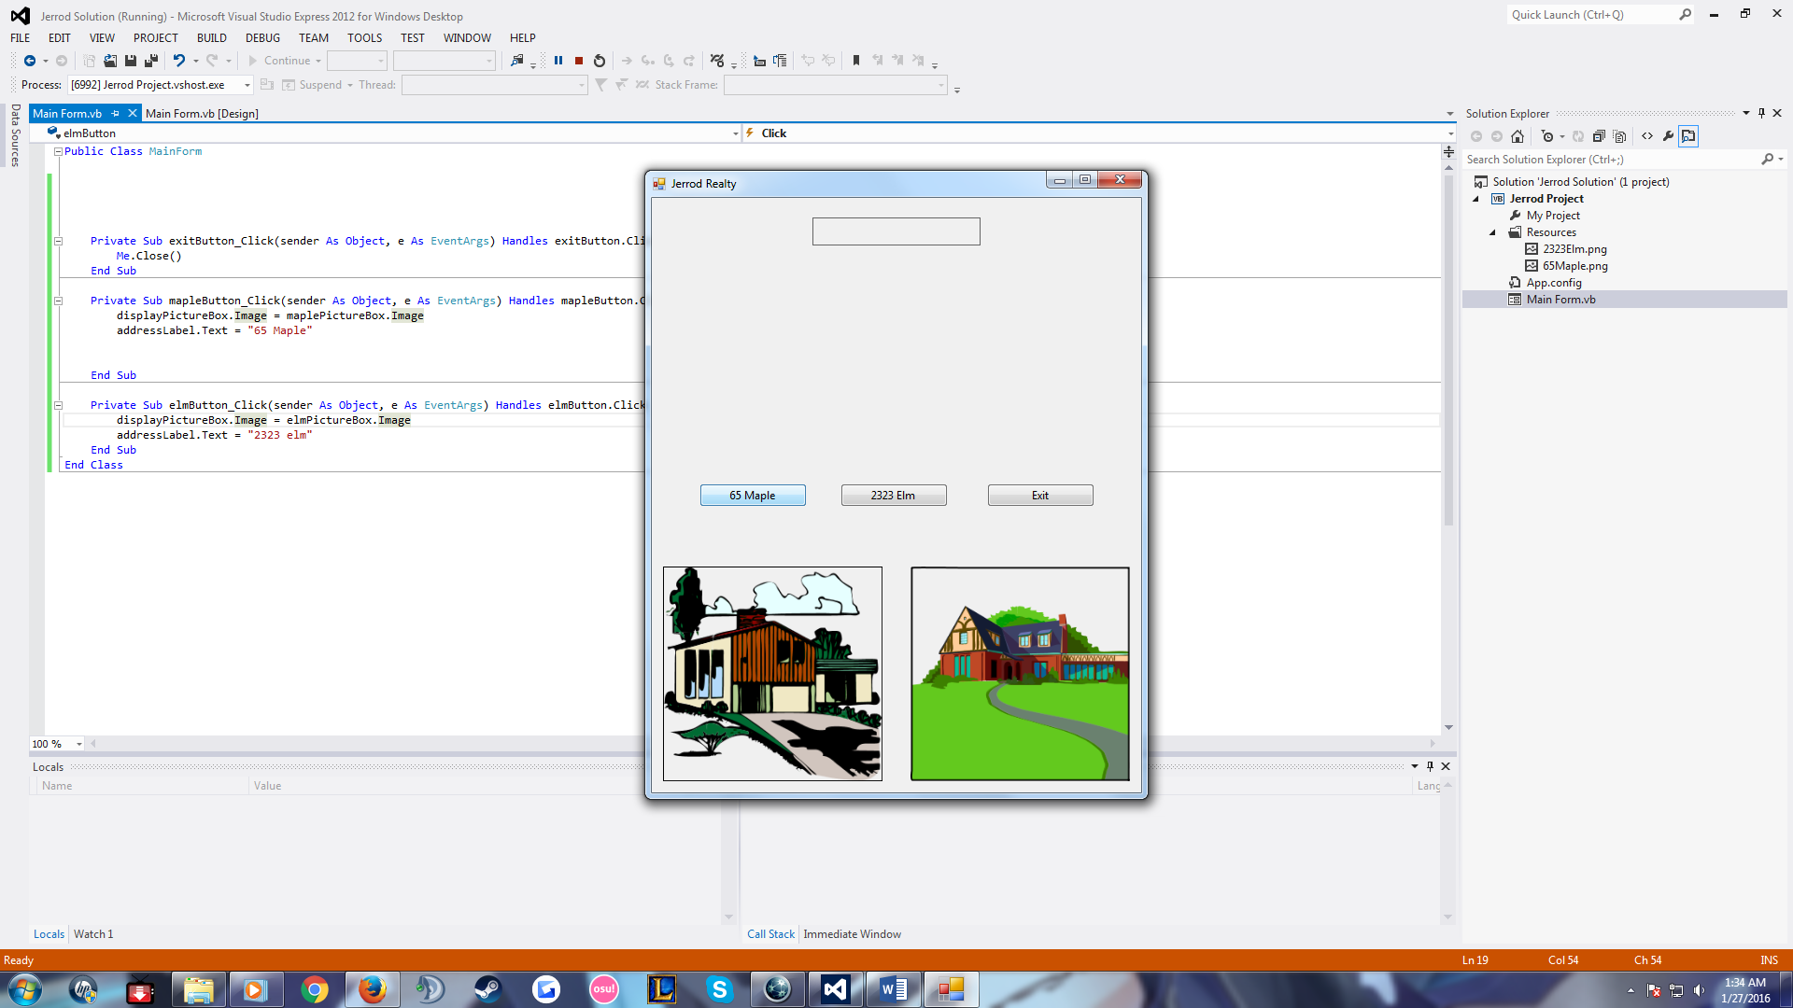

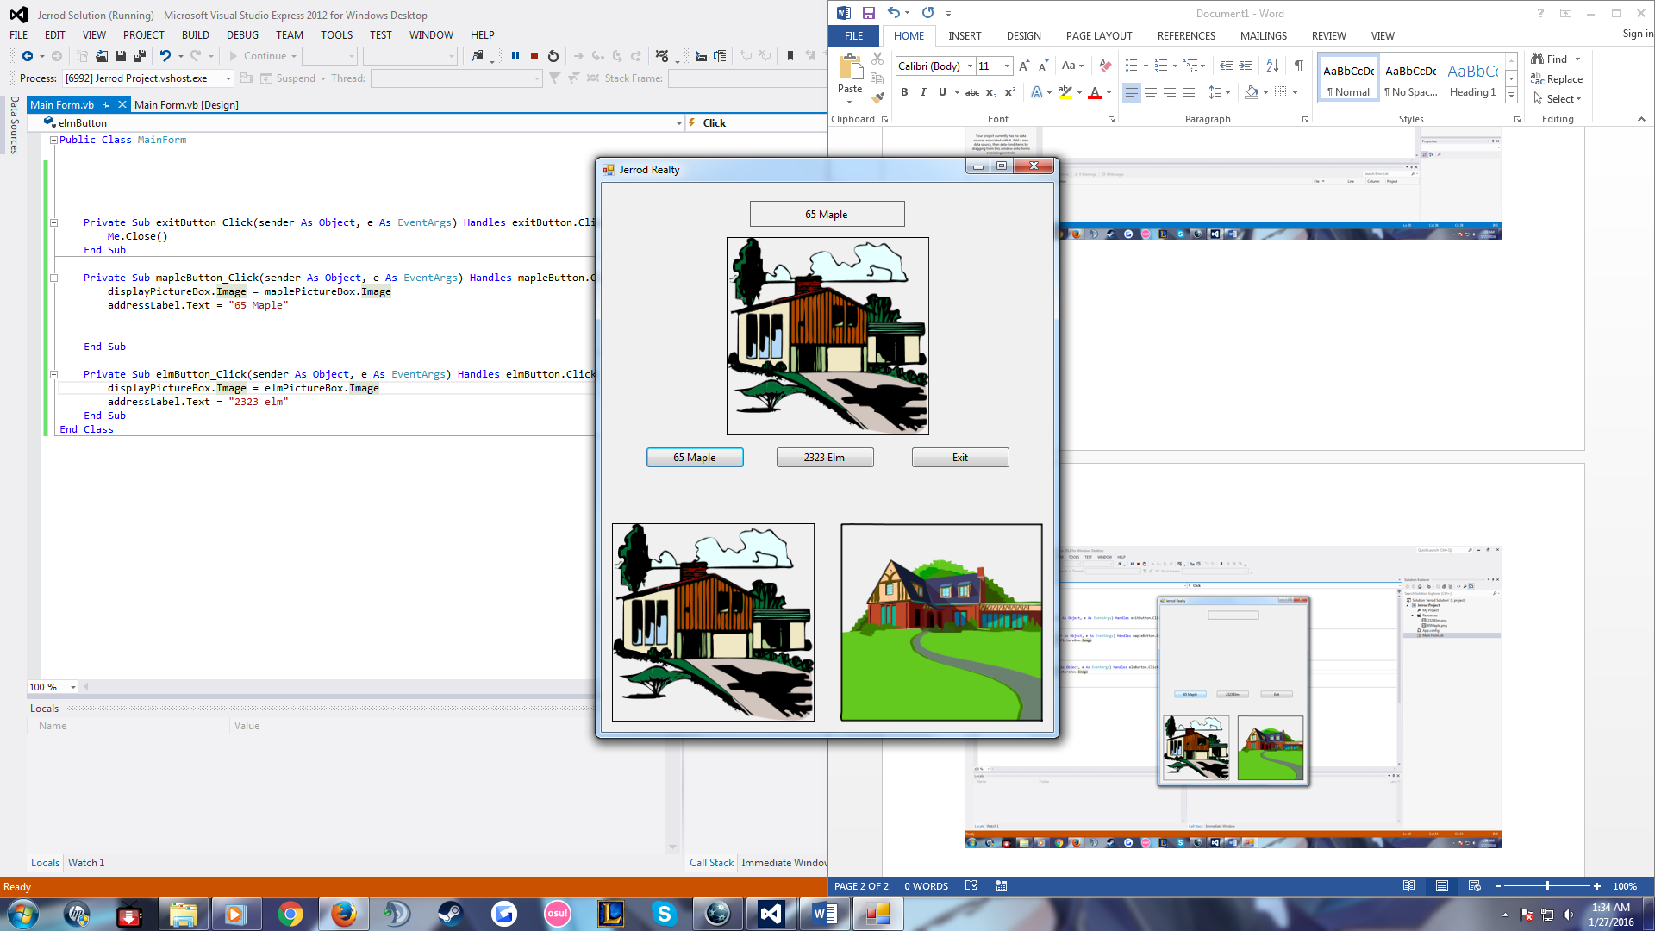

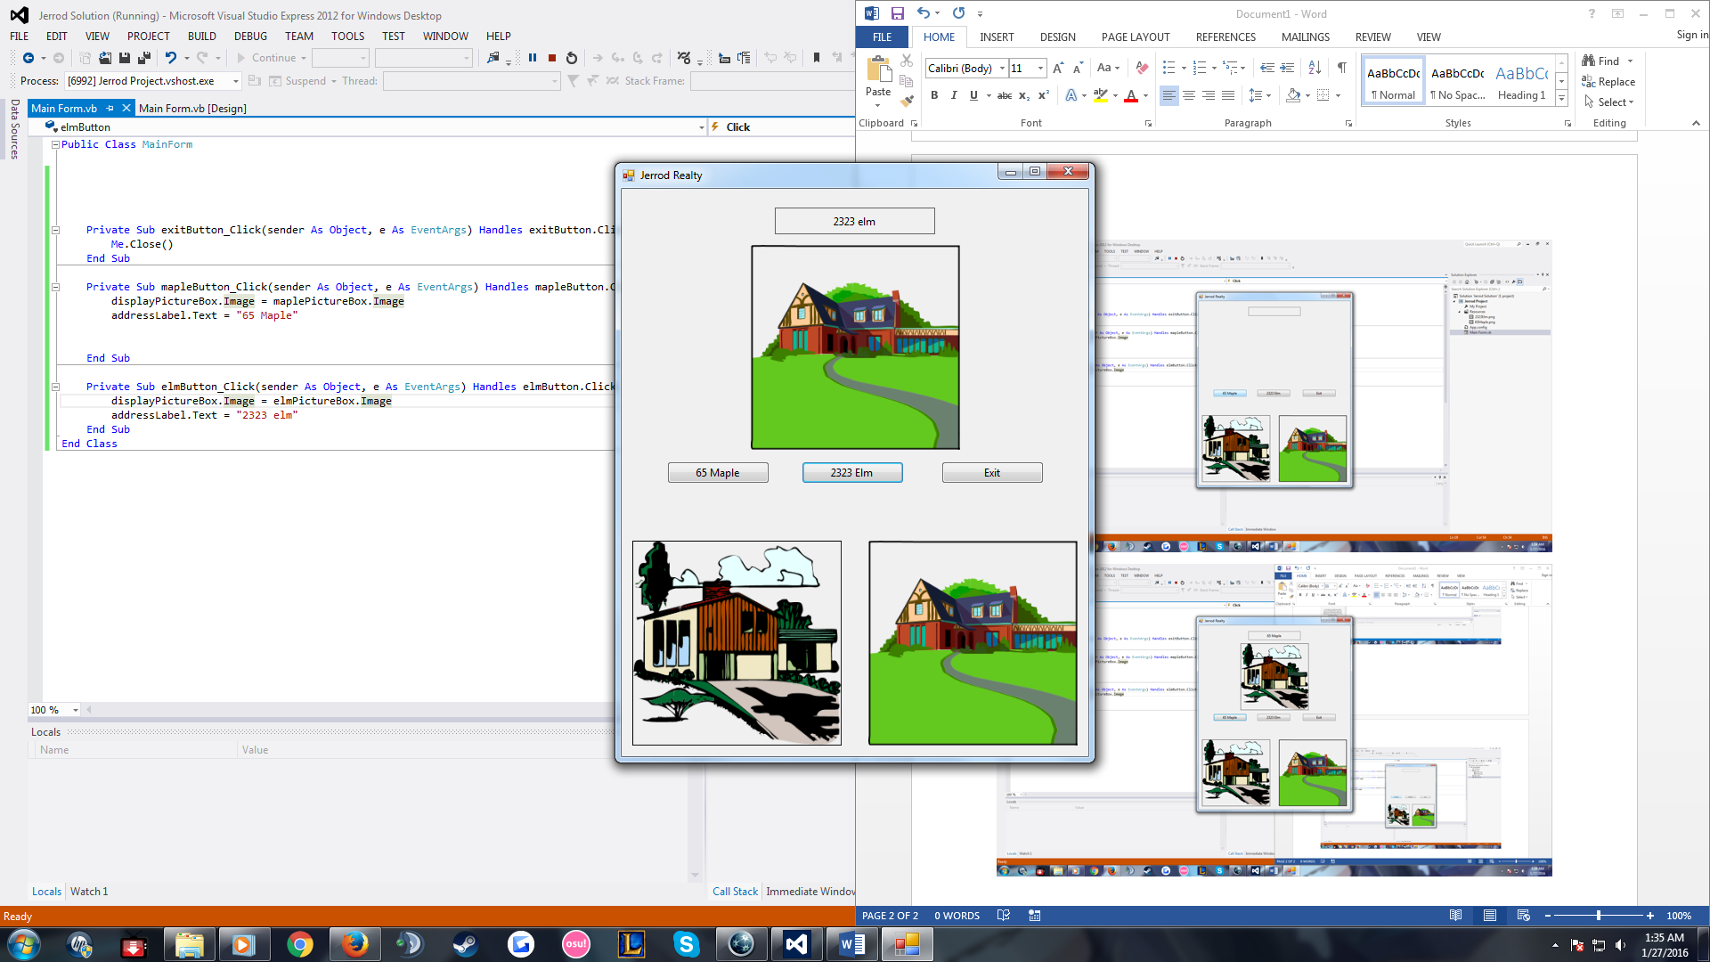

Public Class MainForm

Private Sub exitButton_Click(sender As Object, e As EventArgs) Handles exitButton.Click

Me.Close()

End Sub

Private Sub mapleButton_Click(sender As Object, e As EventArgs) Handles mapleButton.Click

displayPictureBox.Image = maplePictureBox.Image

addressLabel.Text = "65 Maple"

End Sub

Private Sub elmButton_Click(sender As Object, e As EventArgs) Handles elmButton.Click

displayPictureBox.Image = elmPictureBox.Image

addressLabel.Text = "2323 elm"

End Sub

End Class